# Configure a Global Policy

1. Access the Product Assets service configured in Azure API Management in the previous hands-on – <https://pgecommerce.azure-api.net/dam/assets>.
2. Verify the HTTP response headers, and specifically look for the “X-Powered-By” header. Note that the underlying technology implementation is revealed, which may not be ok for certain enterprises from a security standpoint.

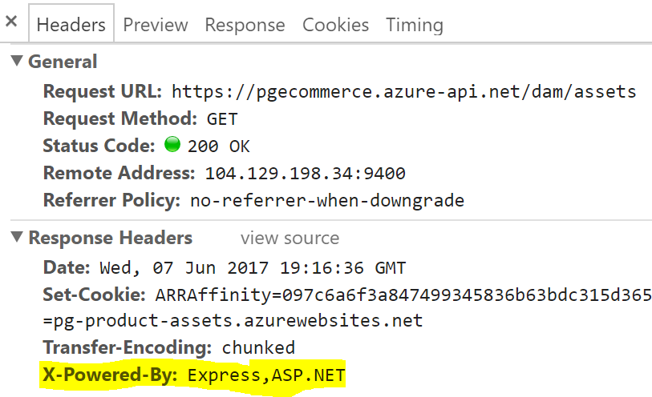

1. Likewise, access the Product Reviews service configured (<https://pgecommerce.azure-api.net/bv/reviews/000080265628>) and verify its HTTP response headers. Note that there is no “X-Powered-By” response header.

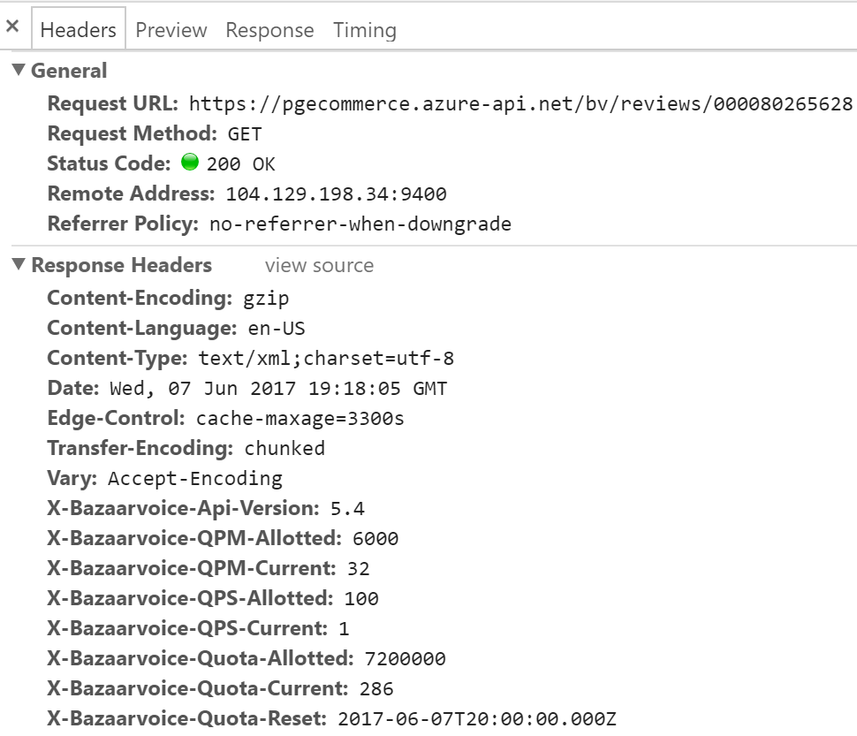

1. Assume there is a need to address the security concern, as well as to have a standard header for all APIs configured in Azure API Management.
2. Go to Publishers Portal 🡪 Policies 🡪 Full Screen 🡪 Configure Policy. Do not filter by a product, API or an operation as this policy is a global one.

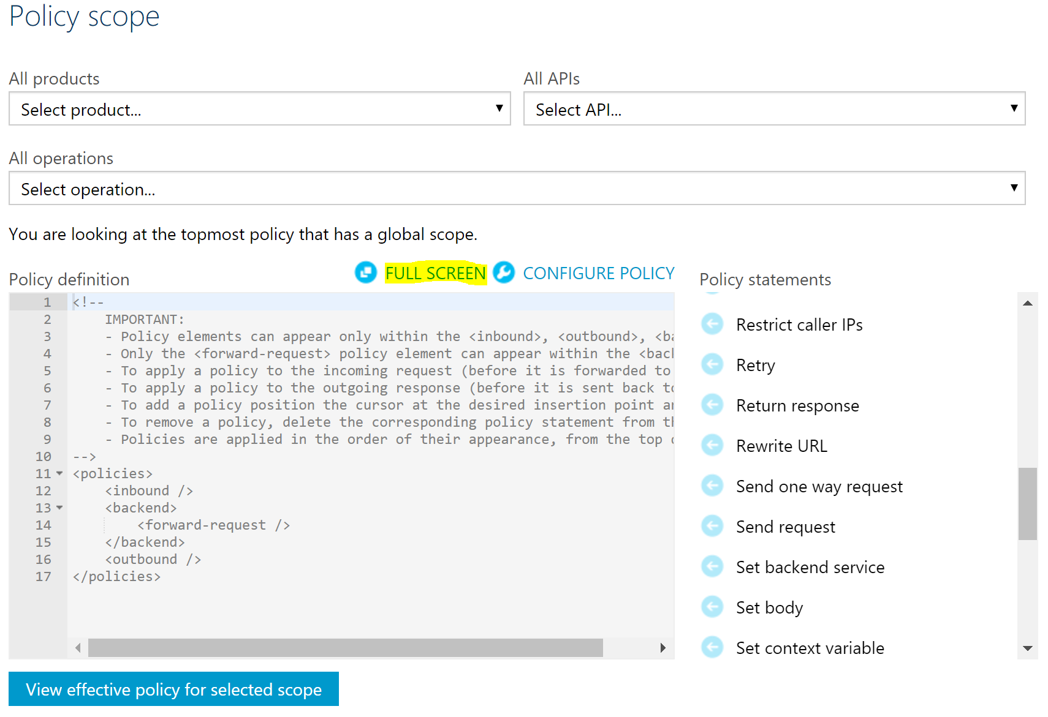

1. Add the “Set HTTP Header” policy to the outbound section of the API, configure values as shown below and Save the configuration.

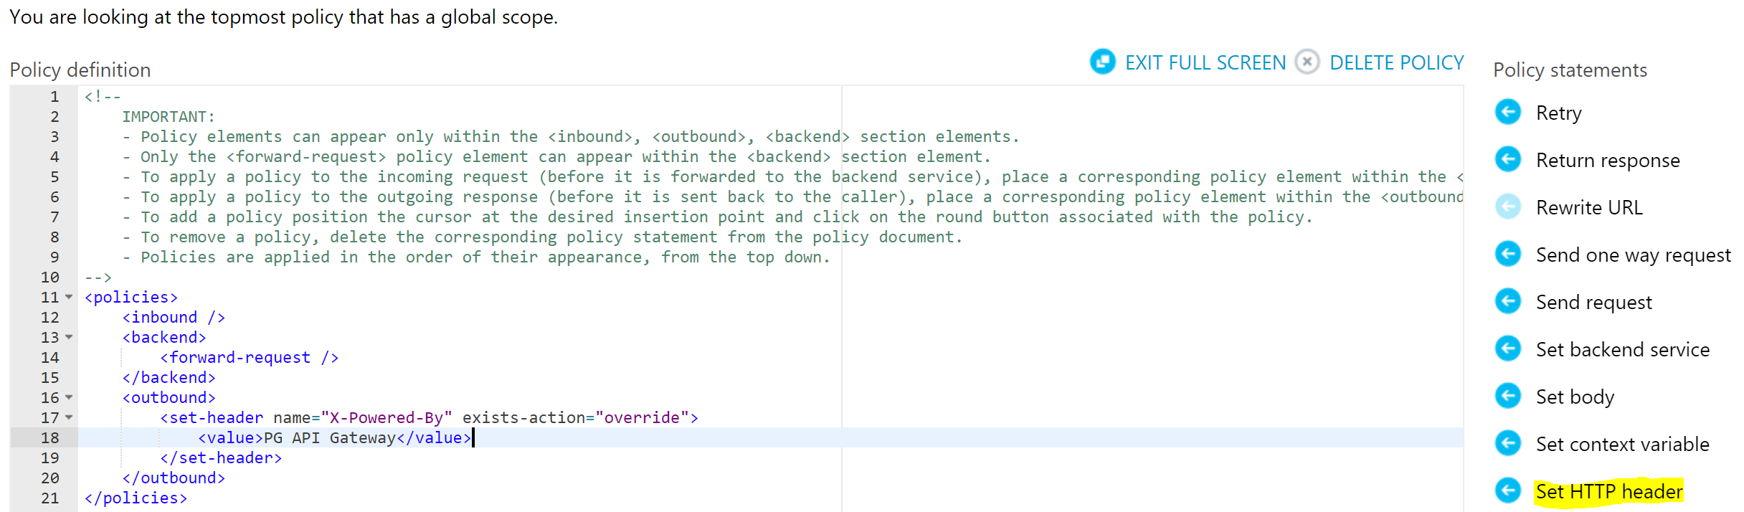

1. Alternatively, replace the policy definition with the content from attached file.



1. Access Product Assets service (<https://pgecommerce.azure-api.net/dam/assets>) and Product Reviews service (<https://pgecommerce.azure-api.net/bv/reviews/000080265628>). Note the new X-Powered-By HTTP header value.

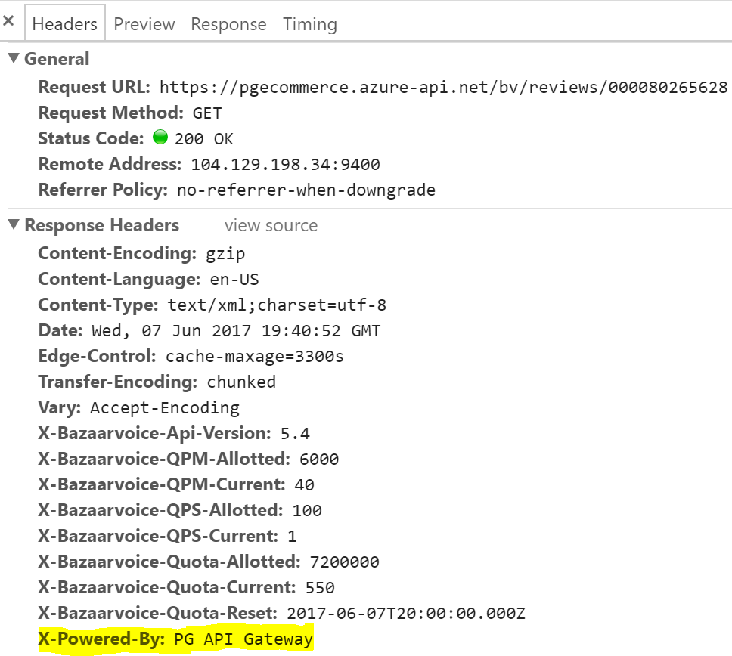 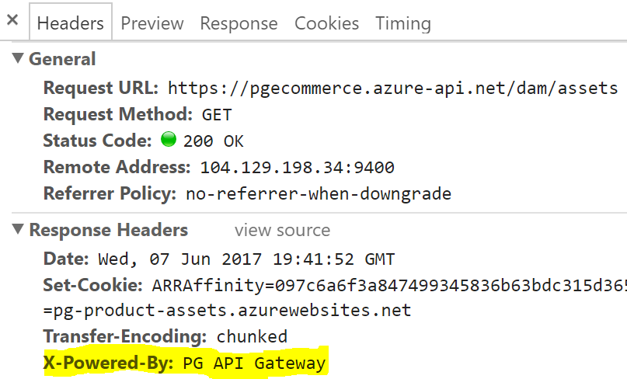

# References

* Policy reference – <https://docs.microsoft.com/en-us/azure/api-management/api-management-policy-reference>
* Policy expressions – <https://docs.microsoft.com/en-us/azure/api-management/api-management-policy-expressions>